Non Profit Donations Web App using REST APIs

Index

1. Environment
2. Functional Brief
3. Database Models
4. REST API Endpoints

**1. ENVIRONMENT**

|  |  |
| --- | --- |
| IDE | Eclipse  Eclipse Java EE IDE for Web Developers.  Version: 2018-09 (4.9.0)  Build id: 20180917-1800 |
| JDK | BUILD_TYPE="commercial"  IMPLEMENTOR="Oracle Corporation"  IMPLEMENTOR_VERSION="18.9"  JAVA_VERSION="11.0.1"  JAVA_VERSION_DATE="2018-10-16"  OS_ARCH="x86_64"  OS_NAME="Windows"  SOURCE=".:657c1504057c open:8513ac27b651" |
| Language | Java with Jax-RS for REST API development |
| Application Server | Apache Tomcat/9.0.12 |
| Database | MS SQL Server 2012 |
| REST API Client | Postman |
| UI Wireframe design | MS Excel 2010 |
|  |  |
|  |  |

**2. FUNCTIONAL BRIEF**

The REST apis developed in this assignment are used for creating a new Donation Type, viewing existing Donation Types, Creating a new donation entry and viewing existing donations.

**3. DATABASE MODELS**

Following database and tables were created:

**Database:** NonProfit

**Tables:** DonationType, Donations

Following commands can be used to create the database, tables and add data to the tables.

Create Database NonProfit

GO

Use [NonProfit]

GO

CREATE TABLE DonationType(

[Id] [int] IDENTITY(1,1) Primary Key NOT NULL,

[DonationType] [nvarchar](50) NOT NULL,

[Description] [nvarchar](max) NULL

)

GO

CREATE TABLE Donations

(

Id INT IDENTITY(1,1) Primary Key NOT NULL,

DonorName VARCHAR(100) NOT NULL,

DonorEmail VARCHAR(100) NULL,

DonorPhone VARCHAR(20) NOT NULL,

DonationType VARCHAR(20) NOT NULL,

DonationAmount INT NOT NULL,

PickUpAddress VARCHAR(MAX) NOT NULL,

PickUpDate DATE NOT NULL,

PickUpTime VARCHAR(20) NOT NULL,

[Status] VARCHAR(20) NOT NULL,

TrackingId VARCHAR(200) NOT NULL

)

GO

--INSERTS for generating data

SET IDENTITY_INSERT [dbo].[DonationType] ON

GO

INSERT [dbo].[DonationType] ([Id], [DonationType], [Description]) VALUES (1, N'Clothes', NULL)

GO

INSERT [dbo].[DonationType] ([Id], [DonationType], [Description]) VALUES (2, N'Food Items', NULL)

GO

INSERT [dbo].[DonationType] ([Id], [DonationType], [Description]) VALUES (3, N'Money', NULL)

GO

INSERT [dbo].[DonationType] ([Id], [DonationType], [Description]) VALUES (4, N'Others', NULL)

GO

INSERT [dbo].[DonationType] ([Id], [DonationType], [Description]) VALUES (5, N'Books', NULL)

GO

INSERT [dbo].[DonationType] ([Id], [DonationType], [Description]) VALUES (6, N'Toys', NULL)

GO

SET IDENTITY_INSERT [dbo].[DonationType] OFF

GO

SET IDENTITY_INSERT [dbo].[Donations] ON

GO

INSERT [dbo].[Donations] ([Id], [DonorName], [DonorEmail], [DonorPhone], [DonationType], [DonationAmount], [PickUpAddress], [PickUpDate], [PickUpTime], [Status], [TrackingId]) VALUES (2, N'Nitin', N'nkb@nitin.com', N'9012145421', N'Clothes', 20, N'123, xyz, 8787, AC', CAST(N'2018-10-31' AS Date), N'12:30', N'PENDING', N'22ec8fb3-2918-4701-8857-cc292b35e354')

GO

SET IDENTITY_INSERT [dbo].[Donations] OFF

GO

The Project carries Model classes for both these tables.

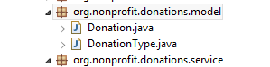

**4. REST API Resources**

1. The very first resource is the Donation Types and these are accessible using this URI

<http://localhost:8080/donations/webapi/donationtypes>

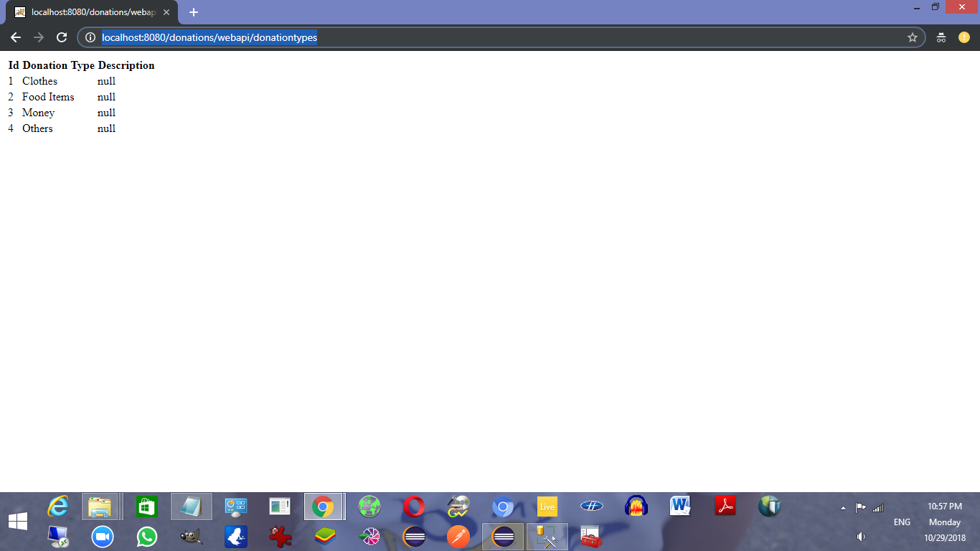

I was able to get the response in HTML format and due to readability I stuck to HTML.

The data is being fetched from the MS SQL Server 2012 database.

Database Name : NonProfit

Table Name: DonationType

This table can be used to add the information of the Donation types that are required.

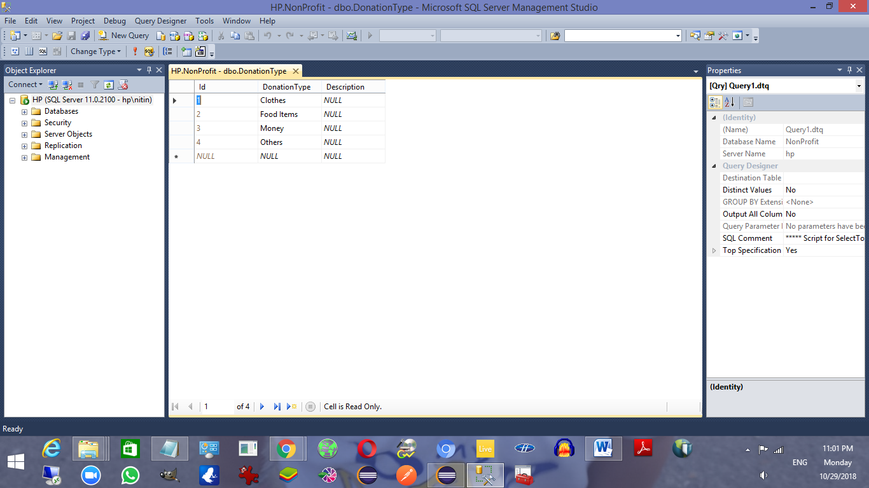

Here is the GET call from Postman:

<http://localhost:8080/donations/webapi/donationtypes>

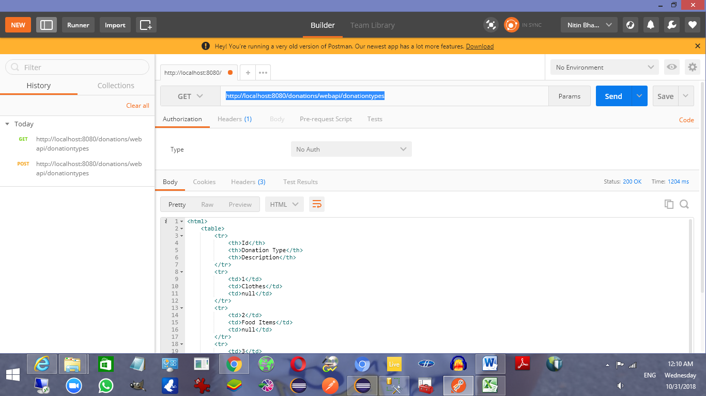

1. To add a Donation Type POST request is being sent with a JSON input with the Donation Type and Description fields and it adds a new row to the DonationType database table.

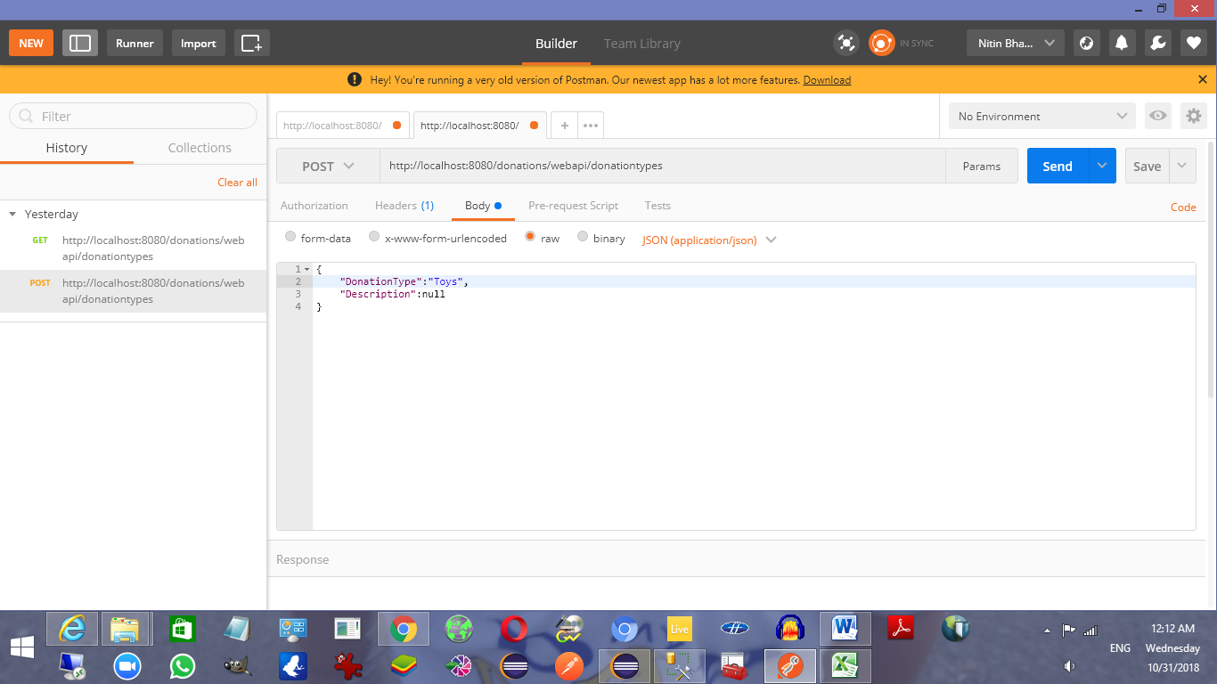

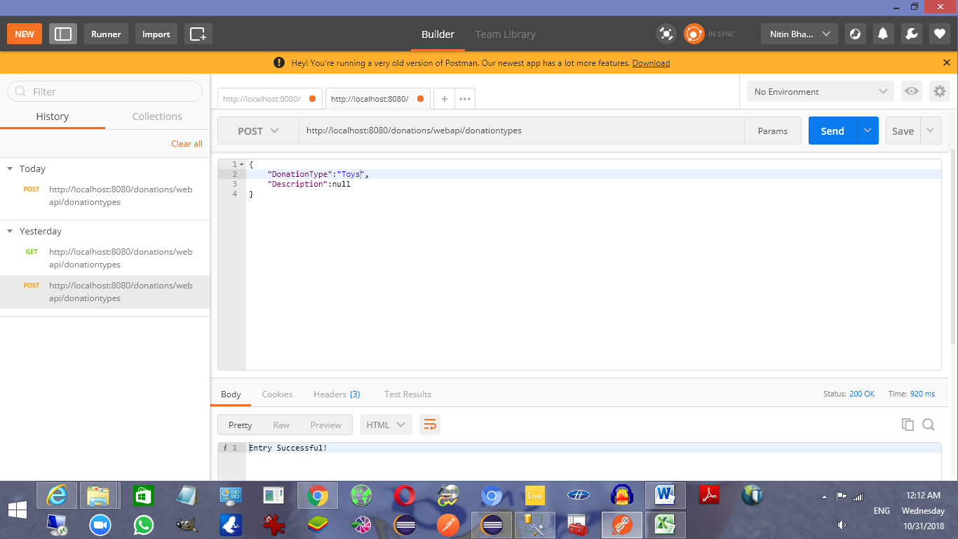

POST call body raw JSON text:

{

"DonationType":"Toys",

"Description":null

}

These are the entries in the database table.

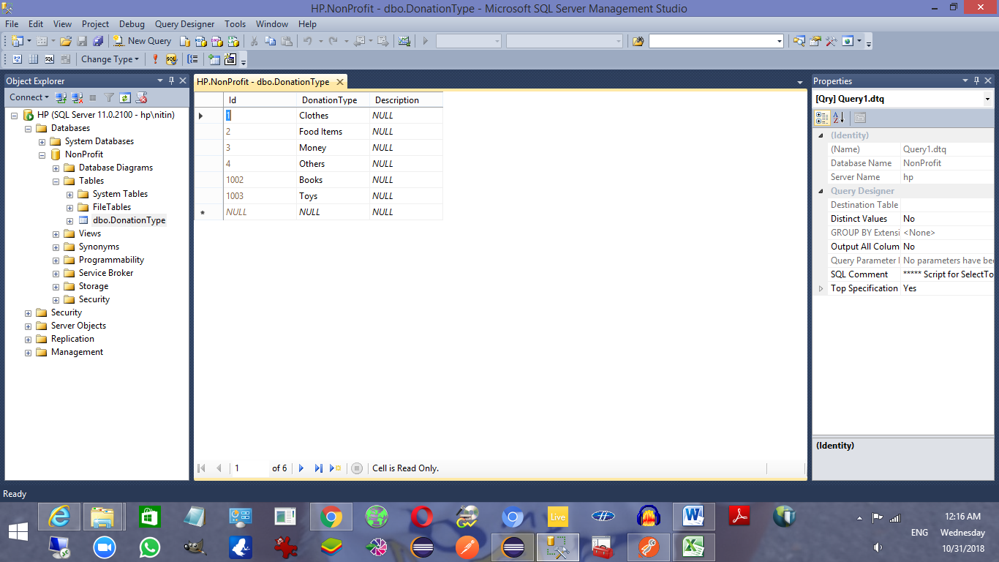

1. GET for viewing existing Donations:

<http://localhost:8080/donations/webapi/donations>

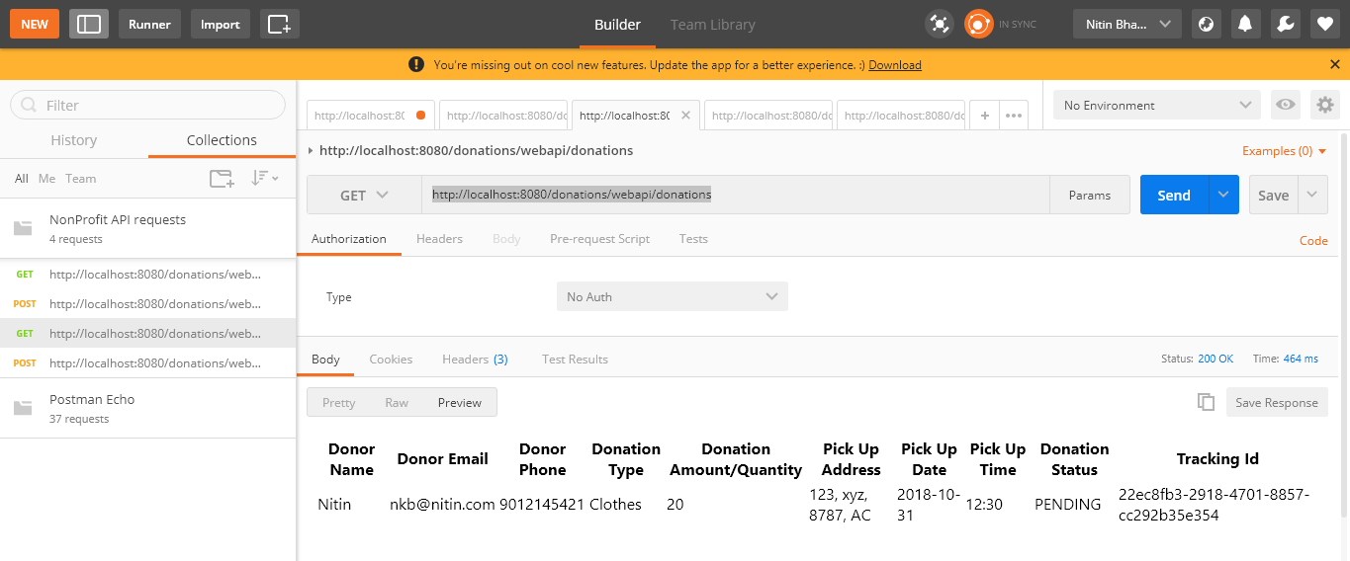

It is written to return and HTML response only.

1. POST for creating a new Donation:

<http://localhost:8080/donations/webapi/donations>

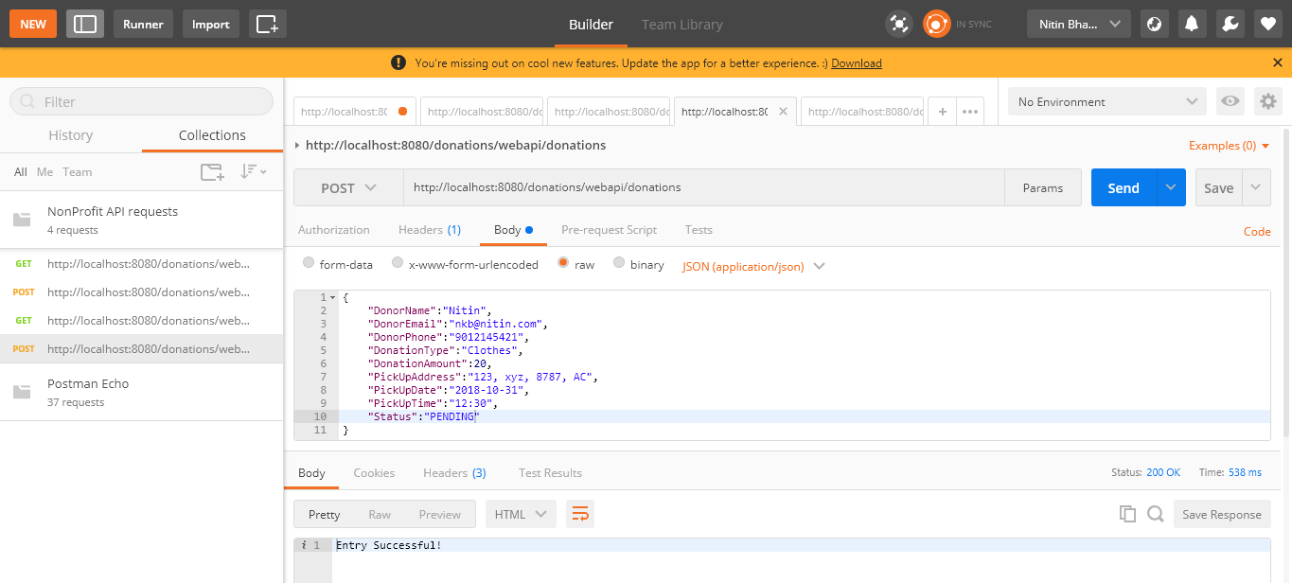

It consumes the JSON format request. Here is the JSON format used:

{

"DonorName":"Nitin",

"DonorEmail":"nkb@nitin.com",

"DonorPhone":"9012145421",

"DonationType":"Clothes",

"DonationAmount":20,

"PickUpAddress":"123, xyz, 8787, AC",

"PickUpDate":"2018-10-31",

"PickUpTime":"12:30",

"Status":"PENDING"

}